**实验三 循环控制 实验报告**

**一、实验目的要求**

1．熟悉用**while**语句，**do-while** 语句和**for**语句实现循环的方法；

2．掌握在程序设计中用循环方法实现各种算法；

3．掌握计算程序运行所占机时的计算方法；

4．上机前按实验要求预习编写出完整的程序，才允许上机。

**二、实验内容**

**内容一**

**3、**

#include<stdio.h>

#include<time.h>

main()

{

int s, a, b, v, m = 0;

clock_t start, finish;

double Total_time;

start = clock();

a = 1;

while (a <= 33)

{

b = 1;

while (b <= 50 - 1.5 * a)

{

v = 100 - a - b;

s = 3 * a + 2 * b + 0.5 * v;

if (s == 100&&v % 2 == 0)

{

printf("大马%d 中马%d 小马%d\n", a, b, v);

m++;

}

b++;

}

a++;

}

printf("共有%d种组合法\n", m);

finish = clock();

Total_time = (double)(finish - start) / CLOCKS_PER_SEC;

printf("运行%f秒\n", Total_time);

}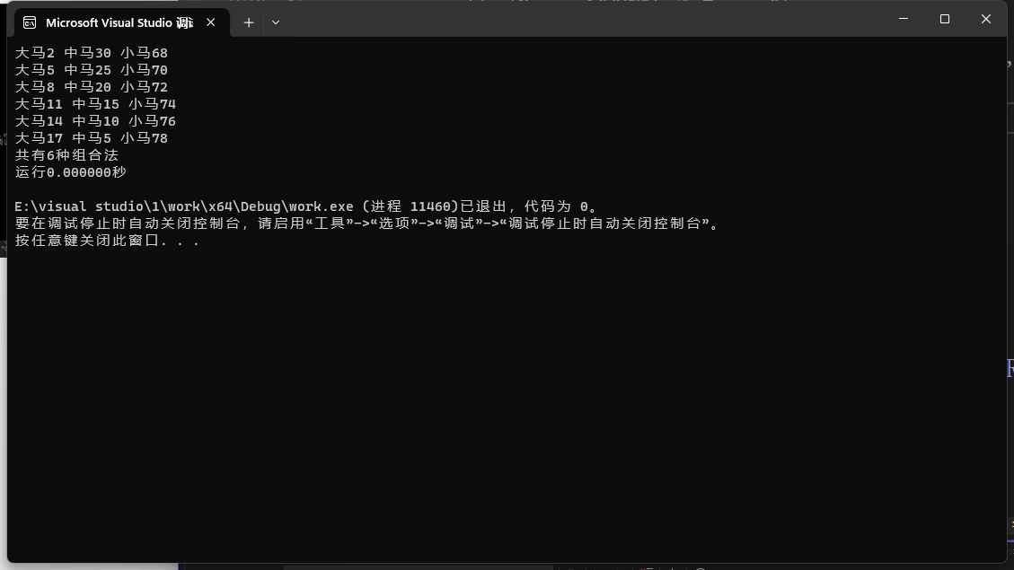

**4、**

#include<stdio.h>

#include<time.h>

main()

{

int s, a, b, v, m = 0;

clock_t start, finish;

double Total_time;

start = clock();

a = 0;

while (a <= 33)

{

b = 0;

while (b <= 50 - 1.5 * a)

{

v = 100 - a - b;

s = 3 * a + 2 * b + 0.5 * v;

if (s == 100 && v % 2 == 0)

{

printf("大马%d 中马%d 小马%d\n", a, b, v);

m++;

}

b++;

}

a++;

}

printf("共有%d种组合法\n", m);

finish = clock();

Total_time = (double)(finish - start) / CLOCKS_PER_SEC;

printf("运行%f秒\n", Total_time);

}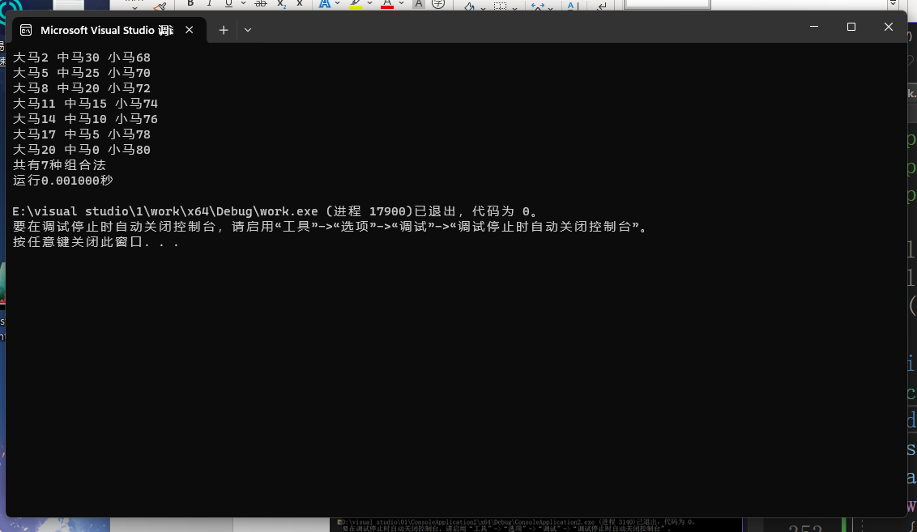

**5、**

**组合法1**

#include<stdio.h>

#include<time.h>

main()

{

int s, a, b, v, m = 0;

clock_t start, finish;

double Total_time;

start = clock();

for (a = 1; a <= 33; a++)

for (b = 1; b <= 50 - 1.5 * a; b++)

{

v = 100 - a - b;

s = 3 * a + 2 * b + 0.5 * v;

if (s == 100&& v % 2 == 0)

{

printf("%d %d %d\n", a, b, v);

m++;

}

}

printf("共有%d种组合法\n", m);

finish = clock();

Total_time = (double)(finish - start) / CLOCKS_PER_SEC;

printf("运行%f秒\n", Total_time);

}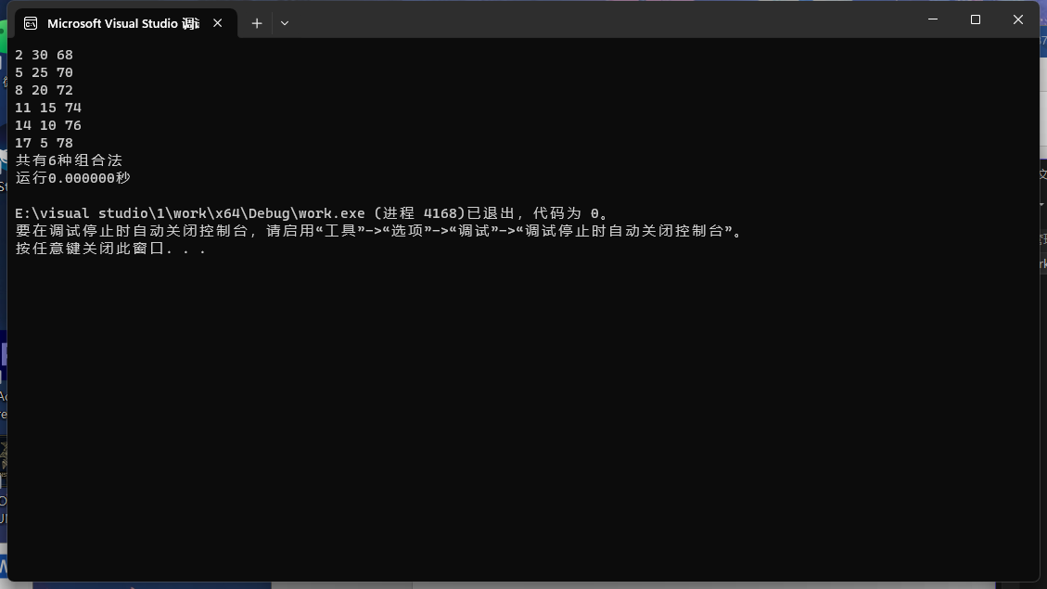

**组合法2**

#include<stdio.h>

#include<time.h>

main()

{

int s, a, b, v, m = 0;

clock_t start, finish;

double Total_time;

start = clock();

for (a = 0; a <= 33; a++)

for (b = 0; b <= 50 - 1.5 * a; b++)

{

v = 100 - a - b;

s = 3 * a + 2 * b + 0.5 * v;

if (s == 100&& v % 2 == 0)

{

printf("%d %d %d\n", a, b, v);

m++;

}

}

printf("共有%d种组合法\n", m);

finish = clock();

Total_time = (double)(finish - start) / CLOCKS_PER_SEC;

printf("运行%f秒\n", Total_time);

}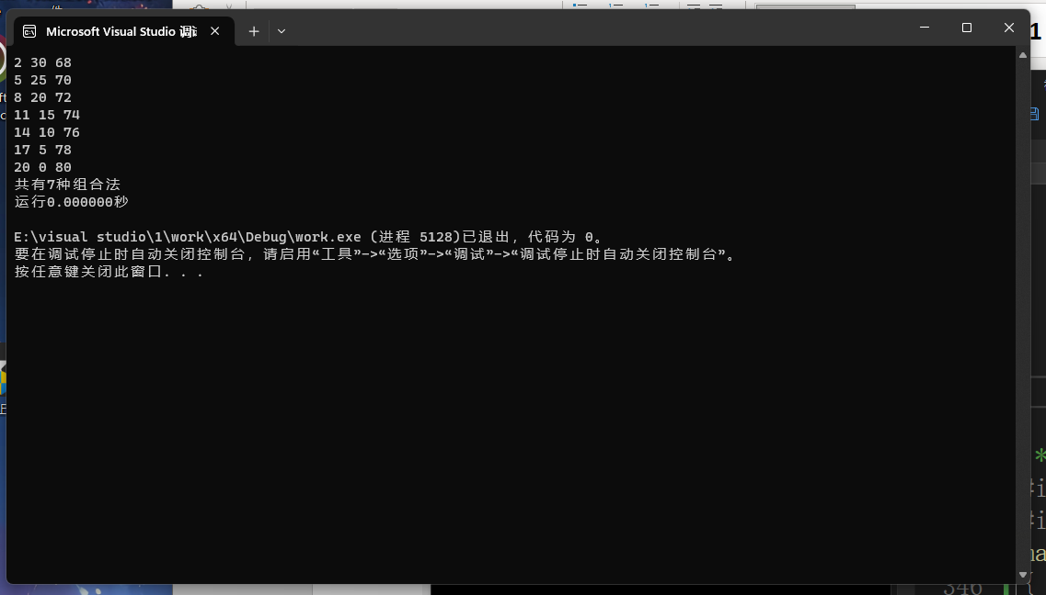

**内容二**

#include<stdio.h>

main()

{

int i, q, p;

for (i = 1; i <= 4; i++)

{

for (q = 1; q <= 4 - i; q++)

printf(" ");

for (p = 1; p <= 2 * i - 1; p++)

printf("*");

printf("\n");

}

for (i = 1; i <= 3; i++)

{

for (q = 1; q <= i; q++)

printf(" ");

for (p = 1; p <= 7 - 2 * i; p++)

printf("*");

printf("\n");

}

}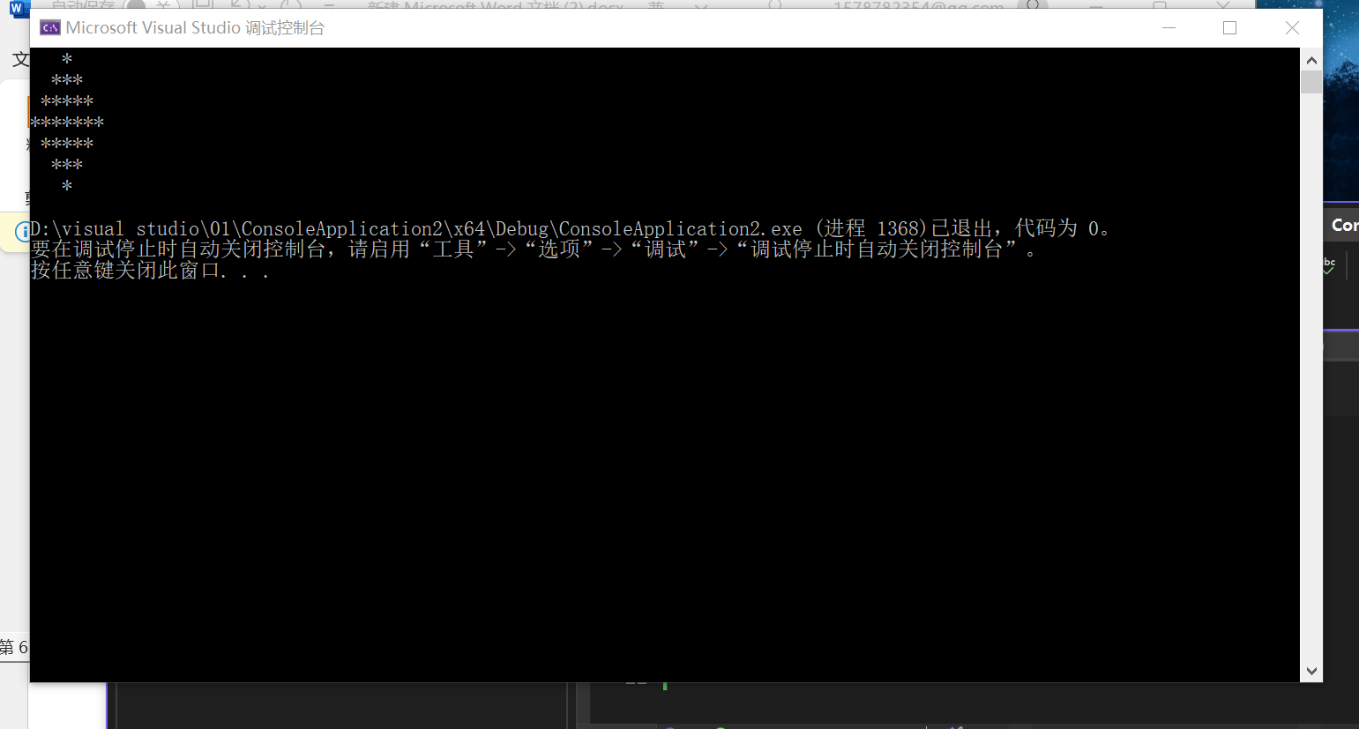

**内容三**

#include<stdio.h>

main()

{

char c;

int i, p = 0, q = 0, r = 0, t = 0;

printf("请输入一行字符:");

c = getchar();

while (c != '\n')

{

if (c >= 65 && c <= 90 || c >= 97 && c <= 122) p++;

else if (c >= 48 && c <= 57) q++;

else if (c == 32) r++;

else t++;

c = getchar();

}

printf("英文字母有%d个\n数字有%d个\n空格有%d个\n其他字符有%d个\n", p, q, r, t);

}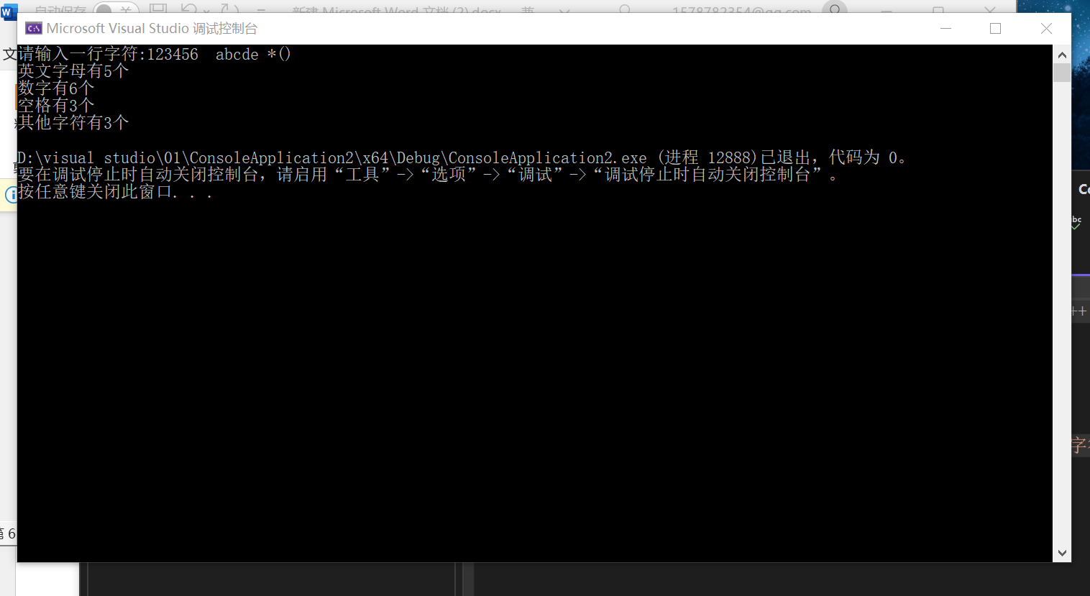

三、思考分析题

1、运行内容如上内容一正确

2、**我对于题目的结果<=和13存在疑惑，以下是本人的运行结果**

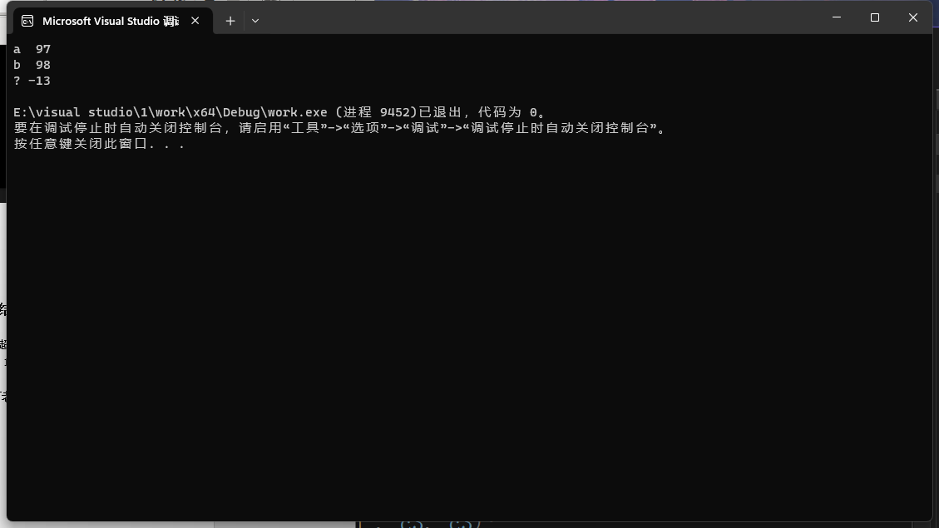

**首先我认为输出的%d(c3)应为-13**

因为char类型变量只能存放-123~127之间的整数，给c3赋值243明显超出这个区间。而243化为二进制为1111 0011，整数又在计算机中以补码形式储存，所以计算机将1111 0011认定为补码，减一取反得到原码为1000 1101，化为十进制即-13。

**其次本人不明白此情况下%c(c3)将以何种形式打印，在此请教一下老师，感谢您的耐心阅读！**